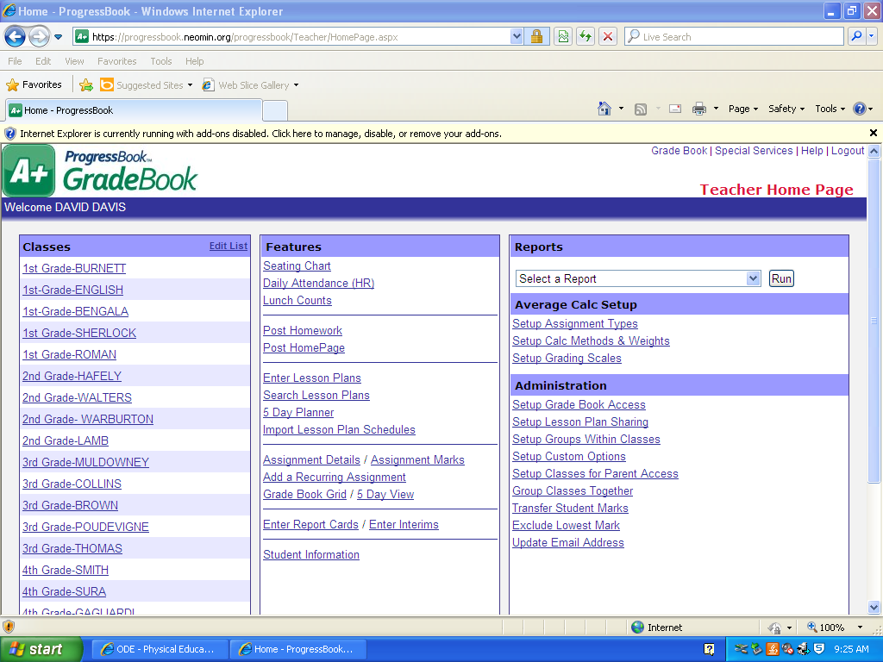
- Sign in to your ProgressBook GradeBook and find the Reports drop-down menu.
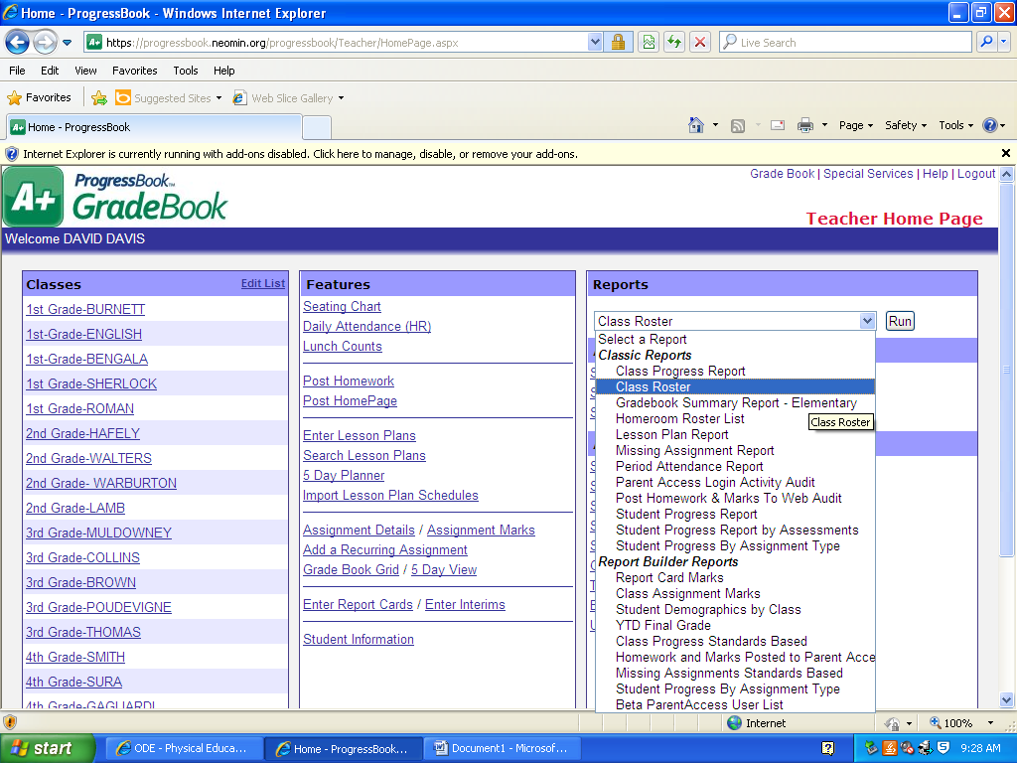
- Select Class Roster from the drop-down list and click Run.
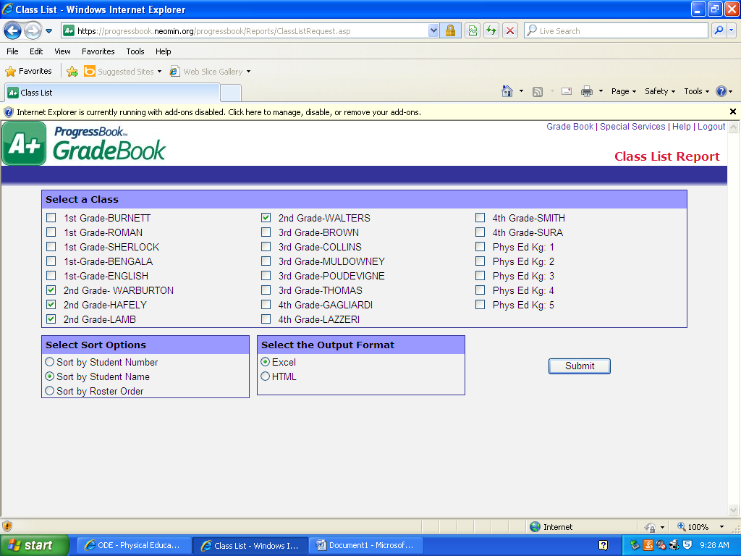
Step 5
Step 4
- Choose the class(es) that you need to copy for your SLO.
Example: All four 2nd grade classes have been checked.
- The Output Format should be Excel.
Note: If the Excel format does not work, the HTML format can be used.
- Click Submit


- Highlight all of the students you need for your SLO.
- Click Copy
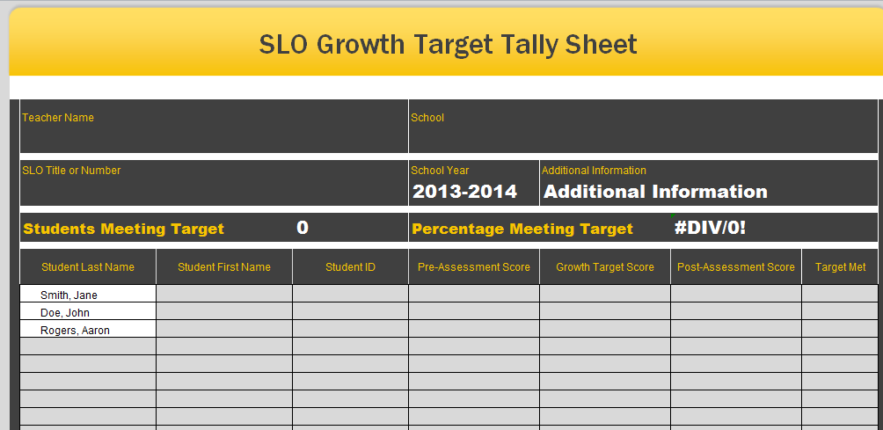
- Open the SLO Growth Target Score (tally) Sheet and click Paste in the Student Last Name column.
Note: Do not worry about splitting the first and last names into two columns, it makes no difference.

You can find the SLO Growth Target Score Sheet by visiting http://www.trumbullesc.org/ImportantSGMResources.aspx

